Creating a Database of Indian Literature: Theory and Practice

*Prakruti Maniar*

*Capstone Project – DIGH 501*

*MA in Digital Humanities, Class of 2021*

## Acknowledgement

I realized that literary discourse in India was centered around English language and Anglo-American works in 2017. It was the first time the need to have a more democratic system of representation presented itself. But without the two years at Loyola University Chicago, with support from the Center for Textual Studies and the course design and cohort of the MA in Digital  Humanities, I would not have been able to envision it, or build the structure that will continue long after this paper.   
  
I want to thank Dr. Elizabeth Hopwood, Dr. Catherine Nichols, Dr. Marta Werner, Dr. Nicoletta  Montana, Seth Green, Elliot Post, and Brian Abrams for being such wonderful professors, and creating classroom environments that were fun, engaging, and tremendously engaging. To the Class of 2020 and the Class of 2021, who have been such a smart, supportive cohort, and whose projects, ideas, and discussions continually inspires and wows me.   
  
To Srijon Sil, Akshay Lakhi, Regina Hong, Abha Nadkarni, and Zachary Stella, for making the time to talk with me at various stages of the project, help clear technical and theoretical doubts, and give critical feedback. To Niamh Mcguigan, Margaret Heller, and Ashley Howedshell for helping me understand how library catalogues classify books, how to use existing standards of Authority Control, and how to use the Dublin Core Metadata Set, respectively. To Troy Bassett, director of the *At the Circulating Library* database of Victorian Fiction, for sharing his .sql file and allowing me to see and borrow from the backend, and for sharing his process of building the database over five years. To the Digital Humanities Alliance for Research and Teaching Innovations (DHARTI) India, for providing the resources and the network that helped me contextualize DH work in the Indian context.

## Abstract

The Digital Humanities body of knowledge produced in the last decade rightfully critiques the manner in which technology dictates our social life, questions the power structures of the digital world, raises concerns about the logics that govern our most-used software.

This paper extends Digital Humanities work to the literary world, to look at the multilingual nature of India, the socio-cultural realities of language and identity-making, its reading culture, the challenges of the literary system, how real-world linguistic unities and divisions play out online, and how existing digital classification systems are inadequate to capture these complexities. Because the underlying systems do not capture the nuances, critical infrastructure to do DH work in Indian literary studies, has not been built, which this paper shows, influences literary discourse even outside academia, to reception of literature in general.

This project designs a classification system which allows for representation of local literatures at the national and global level, using a MySQL database that allows such critical data gathering. The sample dataset of 200 titles reveals the nature of literary traffic in Hindi, Gujarati, Marathi, and English between 1965-1985. The process also exposes the challenges of data gathering, access to creative works, and more.

Finally, it presents a design for a web interface that will use the database to take this work to the public, by democratically representing books in a way that readers can discover them in more than one language at a time, without erasing or othering languages and their literatures.

## A note on terms

## India is used to mean the Republic of India. While it is true that in culture and language, India and South Asia are part of the same group, the scope of this project is situated in India – using source materials from Indian government institutions, borrowing from the publishing trends in the Indian market, as well as the relationship of language and literature in the Indian context

1. Literature is used to mean a creative work – of poetry, fiction, play, or creative non-fiction.

## A brief introduction to language, literature and politics in post-independence India

﻿“A newspaper editor calls on the character of Mario Lawrence, a crossword solver, to create a crossword puzzle based on Bombay rather than importing it from “an award-winning crosswordmaker in London. ‘We want indigenous crosswords...I want Sridevi, Shiv Sena, vada pav in my crossword. I need someone to dig out the names of things, places and people from the gullies of Bombay and fit them into these square grids. It should be our culture, people and food, yaar, not about the Big Ben and the Queen, or that English Breakfast. Forty years since independence and we are still not decolonized, you know what I mean?’ he says.” [1]

This little scene is from a work of fiction, but the situation it illustrates is both real and relatable. The crossword is just one of the cultural products in a whole consignment that has been imported to India from largely the United States of America and England in not just 1979, when the scene takes place, but even in 2020. This import process, recognized as “cultural imperialism” [2], has been made more ubiquitous with the digital turn in cultural consumption as access to all avenues of human expression - movies, songs, clothes, design, books - has become easier and cheaper for the average urban Indian consumer. It is to the general trend in the last industry – that of books – that this project is framed by.

After gaining independence in 1947, language has played a key role in Indian cultural and political life. On the one hand, India adopted English increasingly as a tool for economic progress and used it to educate children to be ready for the global job market. On the other, English helped find common linguistic ground in a country with 14 official languages (before the 1990s. In 2021, the number is 22), and over a thousand mother tongues “classified under 105 languages” [3], coming from four different language families. While the new nation’s constitutional plan was to adopt Hindi as the only official language by 1965, protesters across the country[4] that saw Hindi as imposition of the ruling class in India and especially exclusionary to the Southern and North-eastern states. This led to *The Official Language Act, 1963* [5]*,* which cemented English’s permanent position in the socio-cultural milieu of the nation, wielding hegemony even as it empowered.

In 1981, Salman Rushdie’s *Midnight’s Children* won the Booker prize. This was followed by the global success of other Indian writers who wrote in English, including Arundhati Roy, Vikram Seth, Jhumpa Lahiri.[6] B*hasha* (Hindi for ‘language’, in this paper, to mean any writer in any Indian language besides English) writers, by contrast, became unimportant on both the national and global scale to the reading public outside individual and institutional literary circles. So a Marathi writer was just that, a Marathi writer. His identity as Indian writer was erased in this push for English.

The global publishing industry too started making forays into India. With it came an influx of global literature in the urban Indian markets. It is not surprising that while I grew up speaking four languages, ‘literature’ always meant Anglo-American works written in English. Whether it was the school library or used-books stores in the neighborhood, it was easy to find everything from authors like Enid Blyton and Roald Dahl for children to Sydney Sheldon, Jeffery Archer, Dan Brown, Nicolas Sparks for the older reading public, and books like *Harry Potter, Tintin, Nancy Drew, Famous Five, The Hardy Boys, Princess Diaries*, but hardly any books in *bhashas.*

This paper does not mean to invalidate the use of English, or make a call to replace it with the *bhashas*. This is to lay the foundation of how *bhashas* have been erased by leisurely reading habits of the urban elite – in a metropolis like Mumbai where people come from all over India, one would be hard pressed to find a non-English book in most bookstores.

Several works cited in this paper, most prominently Ananthamurthy, 2015 [7] and Singh and Iyer, 2016 [8] spell out this phenomenon - of erasure of Indian languages and the struggles of the *bhasha* writer to find a place in cultural discussions on the national and global scale - much more eloquently.

Eventually, the number of writers writing in English grew – a strategic move on the part of writers, to shrug off their regional (related to language and state) identities – and the situation has come to be that to be recognized nationally, or globally, an Indian writer must write or be translated into English [9].

### On the digital

If you run a search for ‘Indian authors’ on Google, which, as a “prevailing tool for searching for information, has the power to shape as well as diminish understanding of subjects like Indian Literature” [10], the panels show the following authors.

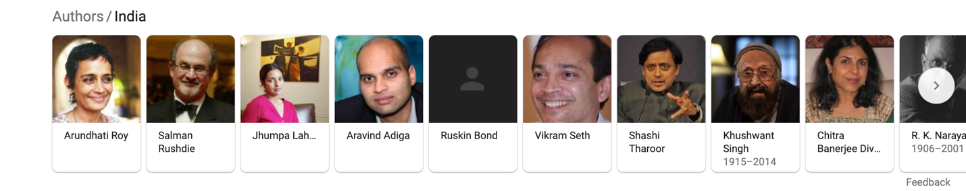

*Figure 1. Screenshot taken on April 17, 2021, 1:00 AM CST*

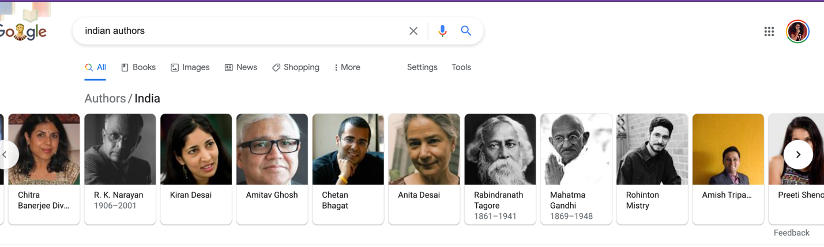

*Figure 2. Screenshot taken on April 17, 2021, 1:00 AM CST*

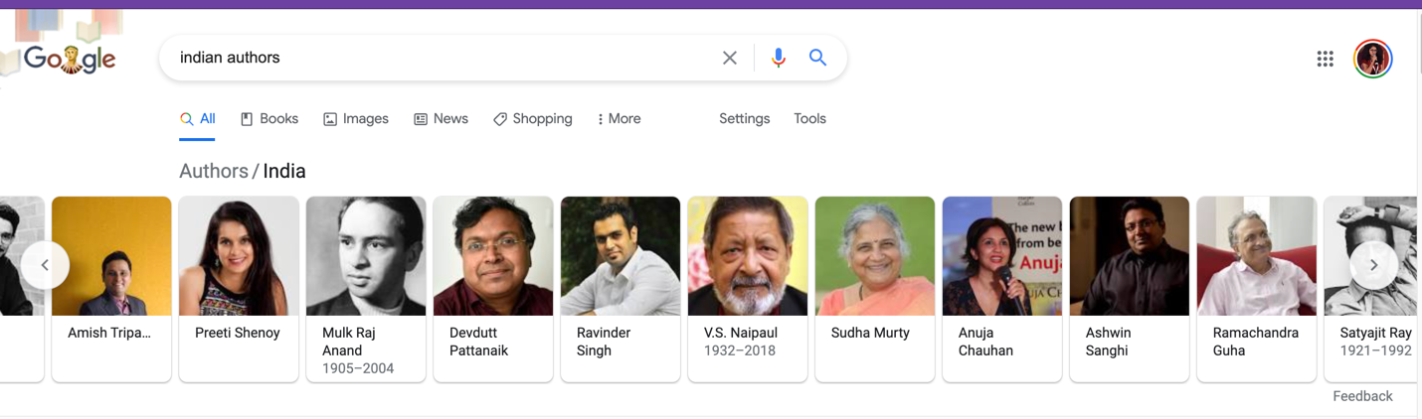

*Figure 3. Screenshot taken on April 17, 2021, 1:00 AM CST*

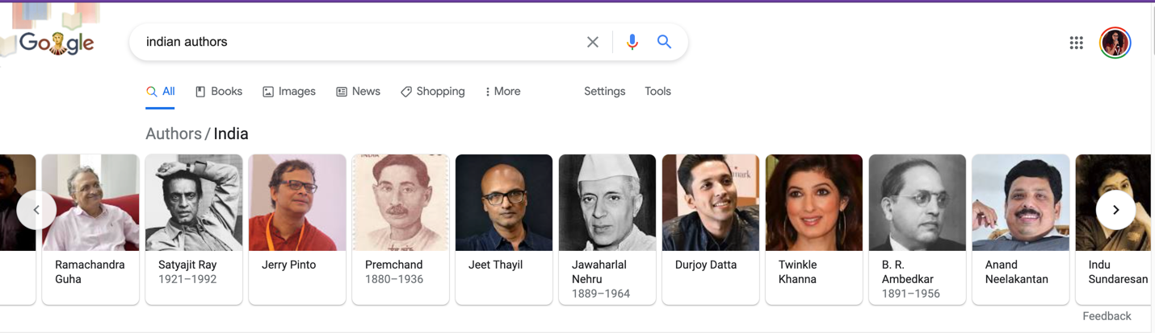

*Figure 4. Screenshot taken on April 17, 2021, 1:00 AM CST*

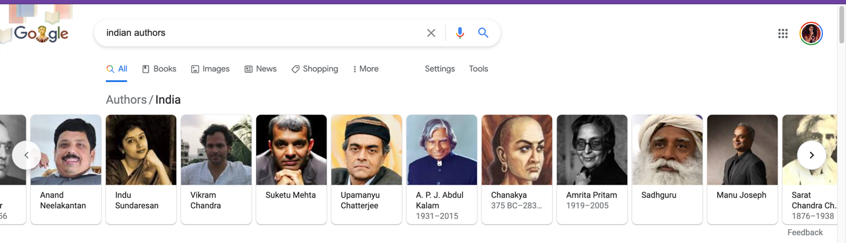

*Figure 5. Screenshot taken on April 17, 2021, 1:00 AM CST*

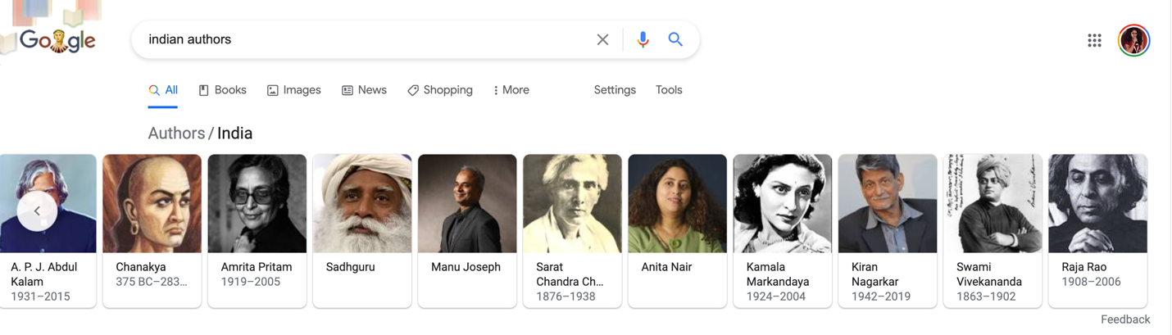

*Figure 6. Screenshot taken on April 17, 2021, 1:00 AM CST*

All but five of these authors write originally in English, and others represent only three other languages.

The internet is an important site for reading culture at large today. I conducted a survey about reading habits for readers outside India. Of the 108 respondents, 50 voted that they discover books through ‘Booklists’ online, 34 via ‘Instagram’, 45 via ‘Bookstores’, and 20 answered ‘Goodreads’ (as part of the ‘Other’ option). A similar survey was conducted for Indian readers, and for the same question, 69 of the 161 respondents chose ‘Booklists online’, 48 chose ‘Instagram’, ‘56’ chose Bookstores, and 48 answered to ‘What’s in the news in general’.

When I conducted the survey of Indian readers, I included questions at the intersection of reading and languages. 110 respondents read for leisure at least once a week. 123 respondents speak two or more Indian languages (with 17 speaking more than four Indian languages), but only 28 of them read in a language besides English within a week. When asked the main reason for not reading more often in their mother tongues, 50 of them opted for the option “I see only English online, don’t really come across it in daily browsing.” The second-most picked answer was “I am much slower in reading in anything besides English”, picked by 54 respondents. Some answers in the ‘Other’ box, talked about how non-English stories were not easily available outside their home state, or online.

So while readers are using Internet, the internet itself does not reflect the diversity of the languages that these readers represent.

Let’s head to Goodreads – where under the ‘Explore section’ for Indian literature, the following two images are the first encounters:

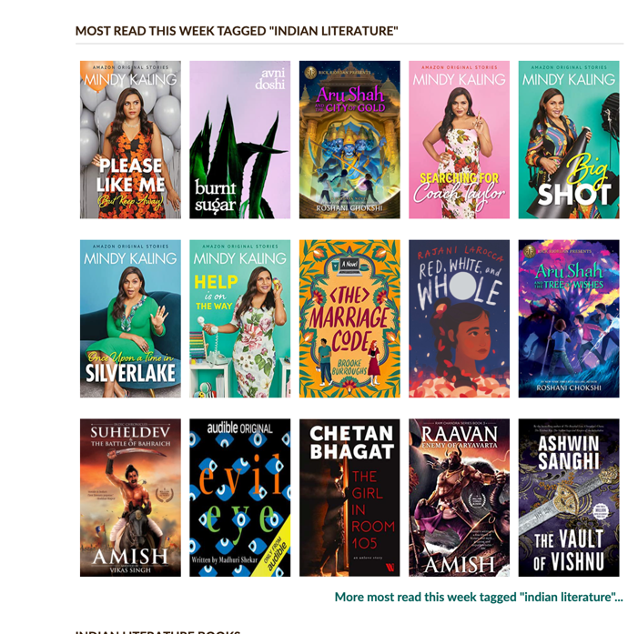

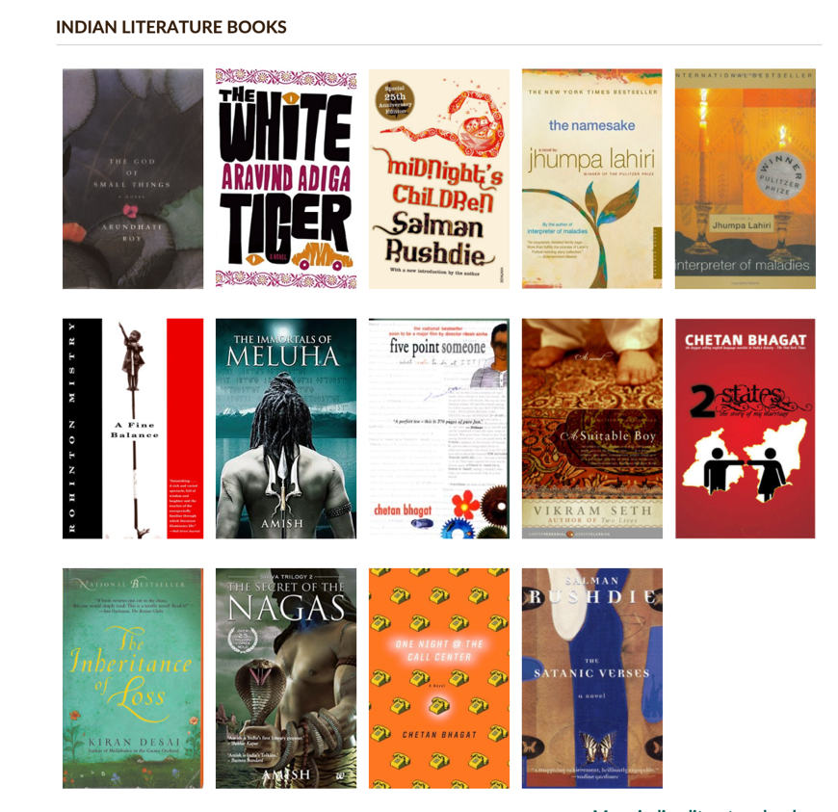

Again, the same story. The first impression is that when one looks for Indian writing, one only sees writing in English. If you look into the ‘Indian Literature’ shelf on Goodreads [11], there are 26,000+ books included. On the first three pages, there are four books in not-English, and they are in Hindi. While subsequent pages do have a select few titles in Kannada, Malayalam, Odia, Marathi, their percentage is miniscule.

The *de facto* association of Indian writer as Indian writer in English is shown even in the language of Wikipedia entries on *bhasha* authors. An Indian writer writing in Marathi is describe as a “Marathi writer”[12] but an Indian writer writing in English is described simply as “Indian writer”.

According to a survey [13], “of the [333 million] literate youth [in India]...the internet is accessed by only 3.7% of youth, of which a mere 4% use it for reading books online and a tiny 1.2% use it to search for book titles. We can assume that the great majority of those with access to the internet have some level of proficiency in the English language.”

It would not be a stretch to say that on the web, it is the English-speaking, English-reading public which creates the *image* of what Indian literature is, which then becomes a standard for those looking outside in. Someone who is not Indian, may not be aware of the complexities and range of languages, would get 1/20th of the picture.

It mirrors the situation off the web, or “reproduces the social world”[14] of literature in India (and perhaps literary discourse across many parts of the world), where “difference is underlined and corroborated by the fact that both writers and readers of particular and individual literature are overwhelmingly concerned with their own literature and own literature only” and masks the nature of the literary system which is best described a “not an entity but an inter-literary condition.” [15] It also masks the nuances of the social world of India, where multilingualism is second nature to a majority of the population, in a situation where “copyrighted algorithms and protocols manipulate and control languages”.[16]

So, for a reader, *bhasha* literatures can only be discovered one at a time. Someone intentionally looking for a representative body of Indian works would have to search for that language, making language a genre in itself, thus ‘othering’ the work in mainstream literary discussion. This leads to a “culture of proxy” [17]- “an Indian writer’s responsibility [is to] representation their nation, and the marginalized writer’s responsibility [within India] to represent their local culture.”

Recent efforts, such as the Indian Novels Collective[18], my own work with Purple Pencil Project[19], the #[bookstagramindia](https://www.instagram.com/explore/tags/bookstagramindia/) or [#litwithindianlit](https://www.instagram.com/explore/tags/litwithindianlit/) hashtags used on Instagram are trying to intervene in this situation, by turning the spotlight on Indian authors. While highlighting the affordances of digital platforms in bringing diverse voices and reading communities together, most of these voices are still only of writers in English. The echo chamber effect of social media is seen here too, where a book that has gained some public attention, gets picked and talked about by the other members of the community. On the two websites, one blog post or one interview at a time, does little to provide a robust, searchable interface like a library or Goodreads.

The overall situation is this: when looking for inclusivity and diversity in Indian literature, using a search engine, which wields enormous power in a “society that is searching” [20] is to look at a very disorganized library, and looking at a specific library is to restrict search to their collections and their arbitrary category making (for eg: see Figure 7). “Discoverability” is a problem of a digital reading culture in general too, as even a global giant like Amazon identified, when it decided to start providing recommendations in its offline bookstore, Amazon Books.[21] All this, points to bad design for information about literature.

Good information design ‘should provide access to information at multiple granularities”.[22] In literature, these multiple granularities would be subjects, languages, authors, year of publication, genres like fiction, non-fiction, poetry, plays and other such categories of classification. But Indian literature, as I have shown, cannot be accessed with ease at that level of granularity in existing interfaces.

**This landscape scan cemented the first need of the project: Use design principles to create an interface that democratically represents information and helps readers discover literature, in a way that does not preference one language over another, yet uses the affordances of English as a bridge language, in bringing “geographically [and linguistically] dispersed [literary] communities”[23] in communication with each other.**

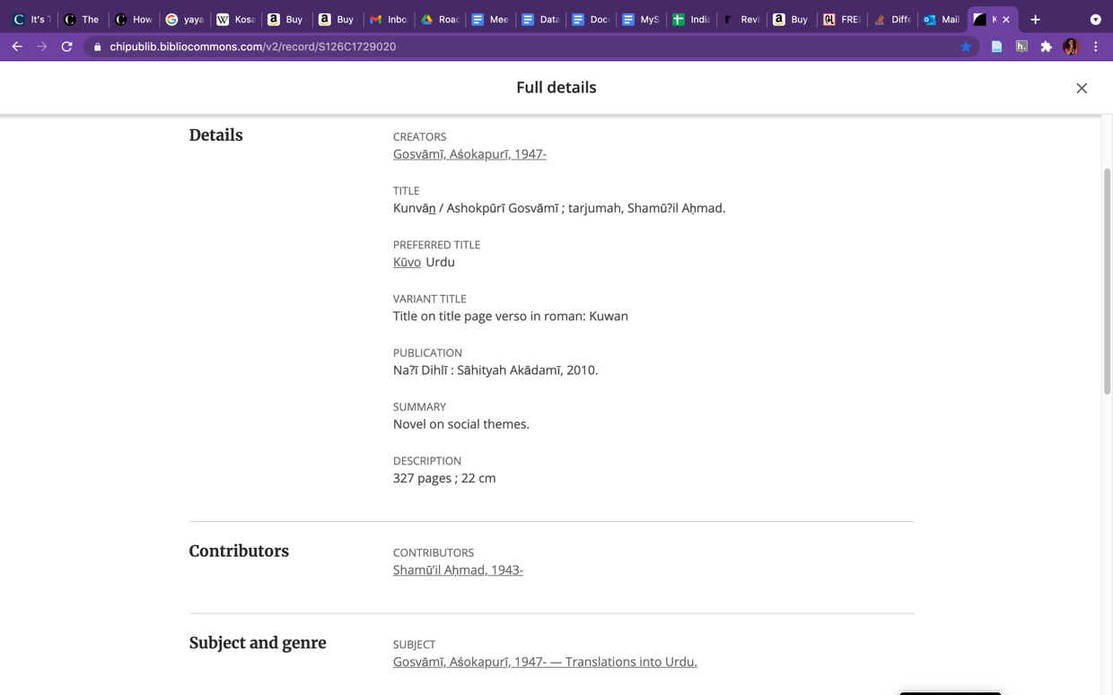

*Figure 7. Screenshot of the Chicago Public Library record of the book Urdu title 'Kunvan'. Taken on April 10, 2021, shows the arbitrary subject-wise categorization.*

## Enter Digital Humanities

In turning the gaze to research in literary studies as a new Digital Humanist in 2019, one of the first things I was struck by were maps and networks, charts and graphs, and how literary data could tell the story of a country, a community, and more, and how data points could be juxtaposed “next to each other”.

Matthew Jockers[24] describes beautifully in *Macroanalysis: Digital Methods and Literary History,* how powerful macroanalysis can be to discover things like if/how social events are reflected in a nation’s literature, or whether the literature “a nation or region produces is a function of demographics, time, population...and so on”, using case studies from British and Irish American fiction.

I read the book in late Fall of 2020 and it made me excessively curious; What could such an analysis of Indian literature tell us about India’s post-independent history? What were the themes of stories being written? What was the relationship between language and literature that emerged during such an analysis?

To answer that question, I needed a corpus, and that corpus had to have books from all Indian languages, and sufficient bibliographical data to draw trends and patterns from.

First, no such corpus exists. As far as having a national bibliography goes, the only body that does a comprehensive work of this kind is the Sahitya Akademi, India’s National Academy of Letters, established in 1954. It’s motto is, “Indian literature is one, though written in many languages”, and towards that end it has launched projects (many of these unfinished or untraceable). It published a five-volume *National Bibliography of Indian Literature* (1901-1954), which was microfilmed for preservation and a digital catalogue created by the *Digital South Asia Library(DSAL)* [25]. The DSAL database, though simplistically designed, provided some of the initial direction to conceive what a digital database could look like. However, it covered a different time period than the one I was looking for. And it focuses as much on religion, philosophy, linguistics, social sciences, as on literature (fiction) and poetry. Because of that, it was not part of the project to weave in thematic genres of the literary and poetry works into their categories.

A second part of the *National Bibliography of Indian Literature* covering the second half of the 20th century, though announced as partially complete on Sahitya Akademi’s website, could not be found online. So the data gathering work had to be done from scratch, in a way (more on that in the process). Other corpora, like the *Two Centuries of Indian Print* project, focus on the 19th century and only largely the state of Bengal and Bengali language works. Sahitya Akademi’s WebOPAC[26] does not have a downloadable data option, and lists books only in its physical library (those published by the Sahitya Akademi itself). Emails and queries to the governing body did not meet with responses.

So the corpus I was looking for was scattered as mentions and citations in critical essays about Indian literature post-independence, on online bookstores in various languages, and needed to be brought together.

Second was design of the database that would hold this corpus. I want to eventually be able to map the literary network – show the inter-*bhasha* translations, be able to analyze popular themes, document literary movements within a time period and within the literature of one language, to then see if there were similarities across India. I need not just a catalogue, but a robust and intentional dataset that would point to trends, a good example of which is *At The Circulating Library*. Were global literary styles like Existentialism or Modernism adopted in Indian literature, both in English and *bhashas*? What were the prominent themes of Indian stories in the years since its independence? What were the literary movements taking place across languages, and were there differences or similarities? This kind of connection making is what would “make the data meaningful and useful.”[27]

**This cemented need to build a corpus of Indian literature, so that it could be used as data to tell a story – of India, its languages, its publics, and the relationship between the three.**

Both these questions, that of a more representative web-interface and that of a corpus for research, rest on one thing – a well-designed database. Databases, datasets, corpora, digitized copies are all part of the “critical infrastructure”[28] that makes Digital Humanities work possible, and are severely lacking for literatures of India. They are also the “model for arrangement of segmented information...within the digital medium” [29], such as a web-interface for readers. And thus emerged the final project.

## Enter the Relational Database

This idea, that Indian literature is actually a network or system of literatures, and the affordances of a relational database of “capturing data about complex systems”, made the need for a *Relational Database Management System* abundantly and immediately clear. I chose the MySQL RDBMS as it is the engine WordPress uses, and the public-facing aspect of the work would be on Purple Pencil Project, which uses WordPress.

In designing the database, I kept a key principle of good information and good databases design in mind: that to find information with ease and with flexibility, labels must be attached with appropriate levels of granularity, and the design should make this happen. [30]

I also borrowed from case studies such as *Wampum, Sequoyan, and Story: Decolonizing the Digital Archive* to be mindful of the idea of decolonizing the database, so that it would:

1. Preserve the “context of collection”
2. Recognize how an “artefact”, in this case the book and the story, works in “mediating knowledge for the user or onlooker...and an object becomes ‘dead’ and no longer used”, and not reproduce that lens of a ‘dead’ past. Towards that, I provided a link, as much as possible, to places where these books could be bought or borrowed or read online. And included a blurb for all books I could find, along with their lose translations
3. “Preserve the language” – so preference, where possible and feasible, to use the original language over English. Also, to use language as separate table, so books could be mapped to it, and even searched by language. This addresses one of the biggest design flaws of Goodreads, which mentions edition language, but a user cannot use it as an index.
4. Give a contextual “sense of time and tradition” [31]- Included a table for ‘literary movements’ that would capture both globally relevant and locally unique literary movements and traditions, to add that layer of context and understanding of how literature and social life intersect

To ensure that, I started with the most common denominators of any literary history; “succession in time, distribution in space, and likeness and difference in character.”[32] This translated to year, place of publication, formats of the books (fiction, non-fiction, poetry, drama) and the themes they fell under, and built up from it.

Other specificities of the database design:

1. To capture bibliographical data that would help readers in general, and researcher to ask the kind of questions outlined at the beginning of this paper – genres, themes, title (in the original and the translation), contributor, language, traditions, blurb (in the original and the translation), year.
2. In India, states are linguistically divided, so geography and language have a close association. But I wanted to decouple that, to figuratively erase these boundaries that have divided languages in India. So I did not include the ‘State’ field. States are also always changing, and boundaries may be redrawn, or new states with the same official language may emerge.
3. Track books in their various languages. The Sahitya Akademi has supported significant amount of translations from one Indian language to another, and there has been significant amount of translation done into English as a general publishing trend. Being able to map books to their translations (which Goodreads does in the form of an edition picker), would also provide a user-friendly way for discovering books. So if a reader does not read a Bengali book, but there are translations into languages they read, it would bring the book and the user closer.

The .sql file can be found [on GitHub](https://github.com/PrakrutiM/Database_Of_Indian_Literature). It is a private repository at the moment (discussed in the data-management plan).

### A note the database design

To make possible the kind of granular data collection and retrieval possible, there were some key considerations while building the database

1. Books were entered in two separate tables: ‘books’ and ‘translations’. This would ensure one could be mapped to another, and create not a linear hierarchy of editions (for eg: like Goodreads does), but a lateral connection that established a network (when doing research) and acts as a direct pointer (when browsing as a reader).
2. Splitting the genre into two kinds broader categories – one pertaining to themes (or subjects), and the other to the categories of fiction, non-fiction, poetry, and play. In my experiences on book discovery, books were always under one broad category of “fiction” or under some other genres such as “comics” or “LGBTQ+” or “Classic”. This brings in a lot of arbitrariness, and forces a data manager to choose one over another. For this, themes that were commercial – classic, best-sellers, most-read, award-winning, women-centric – were not included. Instead, the broad categories of fiction, non-fiction, comics, plays, song, folk, and collections of poetry, essays, short-story will be used as values for data validation at the time of data entry.
3. As data was being gathered, there emerged that a lot of books used a particular kind of dialect of an official language. In the table ‘book_language’, another column for dialect was added to capture this detail.

### A note on data gathering

As I mentioned earlier, there was no corpus to begin with. I chose the years 1965-1985, and decided to focus on fiction alone – novels and short-stories, because according to the surveys mentioned at the start of the paper, they were the preferred genres. At the beginning, it was overwhelming to begin to find these books, but then taking a page out of the *Two Centuries of Indian Print* project, I used annual roundups of the literature in each language published in the bi-monthly Sahitya Akademi journal *Indian Literature* from journal issues accessible via the JSTOR database, and some issues of *Journal of South Asian Literature*. There are gaps of some years, so the sample set does not cover every year in the range.

Online translation tools were used for creating translated blurbs (edited after translations were generated) from Gujarati, Hindi, and Marathi to English. They are:

1. <https://www.easyhindityping.com/marathi-to-english-translation>
2. <https://www.easyhindityping.com/hindi-to-english-translation>
3. <https://www.easyhindityping.com/gujarati-to-english-translation>

### A note on eliminations

To keep the focus of the project under control, there were many data points that were eliminated:

1. First publisher of the book
2. Names of magazines and publications
3. References/Influences: As I mention at the very beginning, the literary system in India post-independence has been deeply influenced by the West. This shows in the literary works produced – biographies of global authors, direct inspirations from the likes of W.H. Auden, Russian authors. For purposes of scale, I chose not to include these.
4. Editions and edition numbers: Documentation about books and publishing is not easily accessible, and while edition numbers could track the popularity of books over time, this was out of scope for the project
5. Every book of every mentioned writer. Many authors mentioned in this dataset have elaborate Wikipedia entries dedicated to them, which mention all their works. Again, in being intentional about the sample set, and in light of the three months that were dedicated to this phase, I had to ignore several works for the moment
6. Commercial Bibliographical details like: Nature of the physical book (hardback or paperback), number of pages, ISBN-10 (where both ISBN-10 and ISBN-13 were available), weight
7. Awards: India has several hundred literary awards, if all the languages are combined. But I ignored that for this phase too, to keep the project to a manageable scale
8. Adaptations: As I began gathering data, it emerged that India has a rich history of adaptations of books into movies. But this emerged later in the data gathering process, and by then the design for this phase had been locked. Once funded, it would be awesome to create a table to hold that information, and map the multimedia history of a book/story. But for now, it is ignored

### A note on Operational Efficiency

The data gathering for this phase, including translations, was all manually done, and also manually entered. There is undoubtedly a faster way to scrape data using Python, to embed translation within the interface, for at least some major Indian languages, and to use more powerful SQL queries on intermediary tables. But my current level of technical expertise, and the scattered nature of data, did not allow it.

## The Web Interface: Wireframes

Wireframes available at: <https://uvov9u.axshare.com>

A note on how some key the web interface design decisions are influenced by the arguments made in the paper:

1. On the landing page, under the ‘Select Criteria’ drop down, I deliberately did not allow languages. This rests on part research and part assumption. As I mentioned earlier, 40% of Indian readers taking the survey replied that they did not read more in their mother tongues because “They did not see it enough”. I wanted to “make visible” the diversity of languages from the get go. The assumption is that if readers are given a choice at the very beginning, confirmation bias may kick in and they may then choose just the language they know
   1. However, there is an option to select languages when choosing the ‘View Random’ book, because if a user is just landing at one particular book, it makes more sense to allow them the option of choosing their language
2. In an effort to preference *bhashas* over English, blurbs for books included in this phase were translated into both languages. However, in the long run, this may be discontinued, as the point is not to make the blurb accessible to every reader who does not read the *bhasha,* but to introduce the idea of multiplicity.

## Preliminary Findings

**Book recommendations!**

1. *Shulamith*: The story of the Bene Israeli Jews in India, and the troubles and discriminations they faced
2. *A Tale with Seven Answers*: Described as a ‘lyrical exposition on Indian social thought’
3. *Mitro Marjani* by Krishna Sobti, in Hindi (translated as)

**Trends**

1. English writing focused on cities and urban life, but Gujarati, Hindi, and Marathi focusing on both.
2. Books in English were more likely to be attributed as “folk” – while the total number of ‘folk’ works was five out of 25, it speaks to perhaps the role of English in bringing “traditional” knowledge to urban Indian settings?
3. Only two Indian books written in English were translated into a *bhasha.* This was interesting, because *bhasha* literature was routinely translated into English, and English books from around the world were also being translated. Were not Indian English stories worth translating into regional languages? Or was translation purely market driven and English writers did not need the *bhasha* markets?

**Miscellaneous**

1. The glaring lack of books online in minor languages such as Sindhi which was the only language, outside of my targeted four, which I captured. I had added only because I came across the mention of these books, but when I sat to search for metadata, this lack of digital access seemed very shocking. It raises questions on the connection between the material and the digital in today’s world; and even though the digital is considered to be the primary source of information, how much is missing on it

## Data Management Plan – Built using the DMP Tool by the Digital Curation Center in UK[33]

----------------------------------------------------------

**Creator:** Prakruti Maniar

Affiliation: Other

Project abstract:

Last modified: 25-04-2021

----------------------------------------------------------

### Data Collection

**What data will you collect or create?** In building the Database of Indian Literature, I will collect, in tabular data format:

*Bibliographical information of the book*

Title

Transliterated Title

Format (fiction narrative, non-fiction narrative, poetry, drama, graphic, illustrated)

Year

Link to online places where books can be access

Themes and subjects the book talks about

Blurb

ISBN or ASIN

*Biographical information of the creators (authors, editors, translators) involved*

First Name, Last Name

Language of Writing

Gender

Wikidata Item URI

Worldcat Identity URI

Other links - where the above two don't exist

Literary Movements they were part of

*Organizational information of publishers*

Name

Location

*The language and script the book was published in\n*

Name of language

System (Written or Oral) and Script used to write the Language

Transliterated Name

ISO 1-2-3 codes for the Languages

Wikidata_URI

*Themes:*

Title

Definition

Other systems of authority control such as BISAC or BIC codes may be incorporated later but were not included in this iteration.  It will be stored in a RDMS, using the MySQL engine, which is also used by WordPress.

The database will be saved in multiple raw files (csv) to ensure long-term and modular access, and continuously updated using GitHub VCS. It is the easiest to transfer between spreadsheet and other data management interfaces like spreadsheets.  Some LOC records, Goodreads lists, publication archives can be used to pull most of the data, though there is nothing that has the complete information. Since this is just cataloguing of information, it should not come across any copyright issues. The data will be about 10GB in this first phase, considering the amount of information. It is saved on the Project Director's Google Drive.

As the project begins to assume its larger role of pan-Indian literature, it will get difficult to manage and a technical team will be brought together to manage it. The current team does not possess the expertise.

### How will the data be collected or created?

The project will follow a multi-pronged approach to collect data:

1. Look at citations in academic literary papers

2. Access lists on Goodreads and other commercial platforms

3. Individually call independent publishers in India to share their catalogue

4. Speak to university libraries for their catalogue, and involve/invite language and literature students to fill it. Potentially crowdsource the data to allow private library owners to put the books online as well

5. Find related data on authors, and publishers, using search queries, interviews, and newspaper and organizational archives

As it is being collected, the data will live in a google spreadsheet in the personal Google Drive of PI, Prakruti Maniar. The individual worksheets within the workbook will be named as per MySQL table and column naming conventions (words separated by underscores instead of camel case).

At this stage, the data will not be checked for quality and accuracy.

### Documentation and Metadata

*What documentation and metadata will accompany the data?*

The data is in English and where applicable, in Indian languages (Gujarati, Hindi, Marathi for Phase 1). The supporting paper on  will provide context for the way the database is designed. Future users may need to have a background in literary studies, South Asian studies, postcolonial studies or a combination of the three.

This will be captured in the seminar paper, and the verbiage of the metadata will also capture the context of Indian literary terms, schools, movements, etc.

I will use an extension of Dublin Core standards, with possible re-interpretations for the user-facing site. Pointers to controlled vocabulary like wikidata and worldcat identities will establish its connection to other databases and vocabularies, in later iterations.

### How will you manage copyright and Intellectual Property Rights (IPR) issues?

At this stage, the database will not have full texts of the books being listed. There will be no IPR issues in the forseeable future.  The data will be partially accessible via GitHub on a case by case basis, but its use by Purple Pencil Project will be co-owned by Saurabh Garg and Prakruti Maniar.

The license will allow for individual, non-commercial use upon request.

The data-sharing will be postponed till about 2500 entries are collected from 1965-1985, featuring an equal proportion of the official Indian languages.

### Storage and Backup

*How will the data be stored and backed up during the research?*

For the first phase, there is sufficient storage available on Google Drive. An additional charge of 10 dollars a month may have to be incurred as it grows in scale. MAMP development environment will be used to build the database in phpMyAdmin and then exported to the Purple Pencil Project database by a more professional team.

The data will also be stored on a private repository on GitHub.

In the event of an incident, cloud storage functionalities will help recover the data, a copy of which will be shared with Saurabh Garg as a preventative measure. There should be no security concerns regarding confidentiality. Backups will be performed monthly.

*How will you manage access and security?*

Since the data is not sensitive and is mean to be open access, these factors will not be taken into account just yet.

Collaborators will be added to the relevant Google Spreadsheet and invited to the private repository.

### Selection and Preservation

Which data are of long-term value and should be retained, shared, and/or preserved?

In the long-term, if an author or publisher wishes to not be featured on the database, their record may have to be destroyed. Care will have to be taken that community stories, if applicable, do not get exploited by commercial use of the database in any way.

The forseeable uses of the data can allow researchers to notice pan-Indian trends in creative publishing immediately after independence, understand the themes and topics covered. Postcolonial researchers and professors can use it to help build a more diverse syllabi, and readers can use it to discover books using more granular categories. It will also help in a democratic representation of what Indian literature means.

The data will be retained and preserved under Purple Pencil Project. It may move into a more stable academic or governmental infrastructure depending on the funding agency that comes to be involved, and/or the institutions that enter into collaborations with the current team.

*What is the long-term preservation plan for the dataset?*

The long-term preservation plan is to let it live under Purple Pencil Project, a user-facing venture to bring together the diverse Indian literary community. The data will not be need to be specially prepared for sharing, only used for public-facing engagement. The cost will be part of the operational costs of P3.

### Data Sharing

*How will you share the data?*

Through the public-facing website and community Purple Pencil Project, the data can be queried.

The dataset as a .csv file, the .sql file of the database can all be found [on GitHub](https://github.com/PrakrutiM/Database_Of_Indian_Literature). The repository is set to private, because I only have data for four languages. I want to enter data over the summer for the rest of the languages for the years in questions, and then give access upon request.

The team is not working on getting a persistent identifier for the data at this point. It will be upon them to clean it, as befits their research interests.

*Are any restrictions on data sharing required?*

While the data itself is not sensitive, it involves collecting and curating information from multiple stakeholders. In keeping the raw files available upon request, it is allowing for use for research, while minimizing the risks of using it for commercial purposes. Where permission is granted, a data use and sharing agreement will be required.

There is a need to keep the data exclusive till the end of summer, so that enough data can be collected to be as representative of India and its languages as possible. Since the purpose is speak to the multilingualism of the country, it should not be released till all languages are represented in a sufficiently uniform way, as much as possible.

### Responsibilities and Resources

*Who will be responsible for data management?*

The PI Prakruti Maniar will be responsible for data management for the phase of the Capstone Project. It will then fall under the management of the Purple Pencil Project team.

*What resources will you require to deliver your plan?*

Yes, for efficient management, there is the requirement of a technically sound Data Management Officer, or for the PI to learn advanced MySQL, and for development on the front end of the website.

The cost of hiring staff for these two roles, on a contractual part-time basis, is $800 per month.

The cost of additional cloud storage is $20-40 per month, and will grow as the size of the database grows.

----------------------------------------------------------

## Next Steps

In many ways, this project is finally a more refined vision of what I wanted to do with Purple Pencil Project, so this is just the start. Immediate next steps include:

1. Complete the dataset over the summer to include other languages in the range of years this project follows
2. Develop a working interface for data entry
3. Write to collaborate with institutions to take this to scale. Parallelly, write a grant application to find funding to do this independently as Purple Pencil Project

In the long-term:

1. Develop online classes to enable users to learn to read in Indian languages
2. Undertake a digitization project for out-of-print copies to make available online
3. Working with public and private libraries in India to bridge the gap between material collections and the digital library

## References

..:: “..:: SAHITYA : Library ::..” Accessed April 21, 2021. <http://sahitya-akademi.gov.in/library/catalogue.jsp>.

..:: “..:: Welcome to Sahitya Akademi - About Us ::..” Accessed April 15, 2021. <http://sahitya-akademi.gov.in/aboutus/about.jsp>.

“101201 Bic2.1 Complete Rev.Pdf.” Accessed April 21, 2021. <https://www.bic.org.uk/files/pdfs/101201%20bic2.1%20complete%20rev.pdf>.

*A History of Indian Literature.* New Delhi :, 1991. <http://hdl.handle.net/2027/inu.30000109204259>.

“About Hindi | Linguistics at Illinois.” Accessed April 15, 2021. <https://linguistics.illinois.edu/hindi/about-hindi>.

Alan Liu. “Toward a Diversity Stack: Digital Humanities and Diversity as Technical Problem.” *PMLA/Publications of the Modern Language Association of America* 135, no. 1 (January 2020): 130–51. <https://doi.org/10.1632/pmla.2020.135.1.130>.

Amritjit Singh and Nalini Iyer. “Introduction: Beyond the Anglophone—Comparative South Asian Literatures.” *Comparative Literature Studies* 53, no. 2 (2016): 209. <https://doi.org/10.5325/complitstudies.53.2.0209>.

ANI. “Rian’s New Translation Platform Powered by Artificial Intelligence (AI).” *Business Standard India*, June 19, 2019. <https://www.business-standard.com/article/news-ani/rian-s-new-translation-platform-powered-by-artificial-intelligence-ai-119061900991_1.html>.

Assmann, Jan, and John Czaplicka. “Collective Memory and Cultural Identity.” *New German Critique*, no. 65 (1995): 125. <https://doi.org/10.2307/488538>.

“At the Circulating Library.” Accessed April 22, 2021. <http://www.victorianresearch.org/atcl/>.

Bates, Marcia J. “The Cascade of Interactions in the Digital Library Interface.” *Information Processing & Management* 38, no. 3 (May 1, 2002): 381–400. <https://doi.org/10.1016/S0306-4573(01)00041-3>.

The Point Magazine. “Beyond the Guilt Tax,” January 29, 2021. <https://thepointmag.com/criticism/beyond-the-guilt-tax/>.

“Bhalchandra Nemade.” In *Wikipedia*, January 29, 2021. <https://en.wikipedia.org/w/index.php?title=Bhalchandra_Nemade&oldid=1003614423>.

“Bhima Bhoi.” In *Wikipedia*, December 27, 2020. <https://en.wikipedia.org/w/index.php?title=Bhima_Bhoi&oldid=996513327>.

Bhushan, Lipika. “The Big Indian Publishing Divide.” *The Daily Guardian* (blog), October 20, 2020. <https://thedailyguardian.com/the-big-indian-publishing-divide/>.

“BISAC Subject Headings List, Literary Collections - Book Industry Study Group.” Accessed April 21, 2021. <https://bisg.org/page/LiteraryCollections>.

Bolam, Mike. “LibGuides: Metadata & Discovery @ Pitt: Linked Data and the Semantic Web.” Accessed March 31, 2021. <https://pitt.libguides.com/metadatadiscovery/linked-data>.

“BOOKS Received for Review in the Year 1984.” *Annals of the Bhandarkar Oriental Research Institute* 65, no. 1/4 (1984): 339–42.

Borges, Jane. *Bombay Balchão*. Tranquebar, 2019. <https://www.amazon.com/Bombay-Balchao-Jane-Borges-ebook/dp/B07Z7PF38P/ref=sr_1_1?dchild=1&keywords=bombay+balchao&qid=1605233293&sr=8-1>.

Bowen, Jennifer. “Moving Library Metadata Toward Linked Data,” 2010, 16.

Brennan, Sheila A. “Public, First.” In *Debates in Digital Humanities 2016*, 2016. <https://dhdebates.gc.cuny.edu/read/untitled/section/55cea9b4-e647-4a15-b421-a899260b15c3>.

Brydon, Diana. “Experimental Writing and Reading across Borders in Decolonizing Contexts.” *Ariel: A Review of International English Literature* 47, no. 1–2 (2016): 27–58. <https://doi.org/10.1353/ari.2016.0001>.

“Building a Digital New York Times: CEO Mark Thompson,” n.d.

Cameron, Fiona, and Sarah Kenderdine, eds. *Theorizing Digital Cultural Heritage a Critical Discourse*. Cambridge, Mass.: MIT Press, 2007. <http://proxy.library.carleton.ca/login?url=http://site.ebrary.com/lib/oculcarleton/Top?id=10190483>.

Canagarajah, A. Suresh. *A Geopolitics Of Academic Writing*. University of Pittsburgh Press, 2002. <https://doi.org/10.2307/j.ctt5hjn6c>.

———. “Communities of Knowledge Construction.” In *A Geopolitics Of Academic Writing*, 50–76, 2002. <https://www.jstor.org/stable/j.ctt5hjn6c.7>.

Chandran. “Into Bhasha and English: Comparative Study of Bhasha and English Translation in India.” *Comparative Literature Studies* 53, no. 2 (2016): 359. <https://doi.org/10.5325/complitstudies.53.2.0359>.

Chandras, Jessica. “Mother Tongue Activism and Language Shift in Multilingual India: Marathi in Pune, Maharashtra.” *Critical Asian Studies* 51, no. 4 (October 2, 2019): 579–96. <https://doi.org/10.1080/14672715.2019.1669202>.

Chaudhuri, Amit. “POLES OF RECOVERY From Dutt to Chaudhuri.” *Interventions* 4, no. 1 (January 1, 2002): 89–105. <https://doi.org/10.1080/13698010120117415>.

Chaudhuri, Rosinka. “Reading Bharatchandra.” *Interventions* 11, no. 3 (November 1, 2009): 316–33. <https://doi.org/10.1080/13698010903323342>.

Cherrstrom, Catherine A., and Carrie J. Boden. “Expanding Role and Potential of Curation in Education: A Systematic Review of the Literature.” *The Reference Librarian* 61, no. 2 (April 2, 2020): 113–32. <https://doi.org/10.1080/02763877.2020.1776191>.

Christopher S. Penn. “Almost Timely News: Hunting Datasets, SEO Keyword Research, Easy GA4 Wins (3/14),” March 14, 2021. <https://mail.google.com/mail/u/0/#inbox>.

Claudia Soria. “WHAT IS DIGITAL LANGUAGE DIVERSITY AND WHY SHOULD WE CARE?” *Linguapax Review* 4 (2016).

Coursera. “Course Promo - National Research University Higher School of Economics.” Accessed October 16, 2020. <https://www.coursera.org/learn/cultural-creative-industries/lecture/372ov/course-promo>.

Creative, Venn. “Building a Digital Library.” The Literary Platform, October 2, 2012. <https://theliteraryplatform.com/news/2012/10/building-a-digital-library/>.

“Cushman - 2021 - Wampum, Sequoyan, and Story Decolonizing the Digi.Pdf,” n.d.

Cushman, Ellen. “Wampum, Sequoyan, and Story: Decolonizing the Digital Archive.” *College English* 76 (November 2013): 22.

Dasgupta, R.K. “WESTERN RESPONSE TO INDIAN LITERATURE.” *INDIAN LITERATURE* 10, no. 1 (March 1967): 5–15.

The British Library. “Data Visualisations.” The British Library. Accessed April 20, 2021. <https://www.bl.uk/early-indian-printed-books/data-visualisation>.

De Kosnik, Abigail. *Rogue Archives: Digital Cultural Memory and Media Fandom*, 2016. <http://ieeexplore.ieee.org/servlet/opac?bknumber=7845160>.

Dee Das. “7 OBSCURE INDIAN NOVELS YOU SHOULD ADD TO YOUR TBR.” *Book Riot* (blog), September 15, 2020. <https://bookriot.com/obscure-indian-novels/>.

Dev, Amiya. “Comparative Literature in India,” 2000, 9. <https://doi.org/10.7771/1481-4374.1093>.

DeVereaux, Constance, and Martin Griffin. *Narrative, Identity, and the Map of Cultural Policy: Once upon a Time in a Globalized World*. Farnham, Surrey, England ; Burlington, VT: Ashgate, 2013.

Dewi, Novita. “Teaching Postcolonial Literature: The ‘Know – What’, the ‘Know – How’ and the ‘Know-Why,’” 2008, 8.

“Digital Humanities Workbench.” Accessed February 8, 2021. <https://www2.fgw.vu.nl/werkbanken/dighum/source_data/data_modelling.php>.

“Digitaldiversityonlineliterature.Pdf,” n.d.

Dixon, Jennifer A. “How to Build a Database.” Library Journal. Accessed February 2, 2021. <https://www.libraryjournal.com?detailStory=How-to-Build-Database>.

“DIY Book Scanner.” Accessed January 30, 2021. <https://www.diybookscanner.org/>.

“Dmponline.” Accessed April 21, 2021. <https://dmponline.dcc.ac.uk/>.

Dodd, Maya and Nidhi Kalra. *Exploring Digital Humanities in India*. Routledge, 2021. <http://www.taylorfrancis.com/books/exploring-digital-humanities-india-maya-dodd-nidhi-kalra/e/10.4324/9781003052302>.

Dombrowski, Quinn. “What’s a ‘Word’: Multilingual DH and the English Default |.” Accessed November 13, 2020. <https://quinndombrowski.com/?q=blog/2020/10/15/whats-word-multilingual-dh-and-english-default>.

Earhart, Amy, and Andrew Jewell. *The American Literature Scholar in the Digital Age*. Ann Arbor, MI: University of Michigan Press, 2010. <https://doi.org/10.3998/etlc.9362034.0001.001>.

“Early Indian Printed Books - The British Library.” Accessed April 21, 2021. <https://www.bl.uk/early-indian-printed-books>.

“EIGHTH SCHEDULE of the Constiution of India,” n.d. <https://www.india.gov.in/sites/upload_files/npi/files/coi-eng-schedules_1-12.pdf>.

“EighthSchedule_19052017.Pdf.” Accessed April 15, 2021. <https://www.mha.gov.in/sites/default/files/EighthSchedule_19052017.pdf>.

English, James F., and Ted Underwood. “Shifting Scales: Between Literature and Social Science.” *Modern Language Quarterly* 77, no. 3 (September 2016): 277–95. <https://doi.org/10.1215/00267929-3570612>.

Fiormonte, Domenico. “Toward a Cultural Critique of Digital Humanities.” In *Debates in the Digital Humanities 2016*, 2016.

“FREE English to Gujarati Translation - Instant Gujarati Translation.” Accessed April 12, 2021. <https://www.easyhindityping.com/english-to-gujarati-translation>.

“FREE Gujarati to English Translation - Instant English Translation.” Accessed April 12, 2021. <https://www.easyhindityping.com/gujarati-to-english-translation>.

“FREE Hindi to English Translation - Instant English Translation.” Accessed April 12, 2021. <https://www.easyhindityping.com/hindi-to-english-translation>.

García-Silva, Andrés, Oscar Corcho, Harith Alani, and Asunción Gómez-Pérez. “Review of the State of the Art: Discovering and Associating Semantics to Tags in Folksonomies.” *The Knowledge Engineering Review* 27, no. 1 (February 22, 2012): 57–85. <https://doi.org/10.1017/S026988891100018X>.

Gleick, James. *The Information: A History, a Theory, a Flood*. 1st Vintage Books ed., 2012. New York: Vintage Books, 2011.

Gold, Matthew K., and Lauren F. Klein, eds. *Debates in the Digital Humanities 2019*. University of Minnesota Press, 2019. <https://doi.org/10.5749/j.ctvg251hk>.

Golding, David, and Kyle Kopsick. “The Colonial Legacy in Cambridge Assessment Literature Syllabi.” *Curriculum Perspectives* 39, no. 1 (April 1, 2019): 7–17. <https://doi.org/10.1007/s41297-018-00062-0>.

Guldi, Jo. “Scholarly Infrastructure as Critical Argument: Nine Principles in a Preliminary Survey of the Bibliographic and Critical Values Expressed by Scholarly Web-Portals for Visualizing Data.” *Digital Humanities Quarterly* 014, no. 3 (September 1, 2020).

Gupta, Ashish. “DESIGN DOCUMENT: BOOKS DATABASE,” n.d., 9.

Gupta, R.K. “On Teaching Indian Literature.” *Indian Literature* 26, no. 4 (1983): 20–34.

Gupta, Suman. “Indian ‘Commercial Fiction’ in English, the Publishing Industry and Youth Culture,” 2020, 9.

fulcrum.org. “Heb08911.0001.001.Epub.” Accessed January 19, 2021. <https://hdl.handle.net.eu1.proxy.openathens.net/2027/fulcrum.9019s3075>.

Routledge & CRC Press. “Hindi Dalit Literature and the Politics of Representation.” Accessed March 16, 2021. <https://www.routledge.com/Hindi-Dalit-Literature-and-the-Politics-of-Representation/Hunt/p/book/9781138660229>.

Holroyd, Carin. “Digital Content Promotion in Japan and South Korea: Government Strategies for an Emerging Economic Sector.” *Asia & the Pacific Policy Studies* 6, no. 3 (September 2019): 290–307. <https://doi.org/10.1002/app5.277>.

Purple Pencil Project. “Home.” Accessed April 20, 2021. <https://www.purplepencilproject.com/>.

“How Hindi Came to Dominate India.” Accessed April 16, 2021. <https://thediplomat.com/2017/05/how-hindi-came-to-dominate-india/>.

“Indian Literature Books | Goodreads.” Accessed April 17, 2021. <https://www.goodreads.com/shelf/show/indian-literature>.

Indian Novels Collective. “Indian Novels Collective :: Home.” Accessed April 20, 2021. <https://indiannovelscollective.com/>.

“International_conference_eg_2020december21_22.Pdf.” Accessed April 17, 2021. <https://www.jmi.ac.in/upload/EventDetail/international_conference_eg_2020december21_22.pdf>.

Iyengar, K.R. Srinivasa. “Renaissance in South Indian Literatures.” *Indian Literature* 17, no. 1/2 (1974): 143–50.

Jacob Strandell. “Culture, Cognition and Behavior in the Pursuit of Self-Esteem.” *Poetics*, no. 54 (2016): 14–24.

Jancy, James. “Literary Research as National Integration: A Tribute to K.M. George.” *Indian Literature* 48, no. 2 (April 2004): 220.

“Jaywant Dalvi.” In *Wikipedia*, April 6, 2021. <https://en.wikipedia.org/w/index.php?title=Jaywant_Dalvi&oldid=1016372993>.

jbm399. “Mapping New York City’s Literary History.” CARTO. Accessed October 11, 2020. <https://jbm399.carto.com/viz/8c362eac-c72b-11e6-9c17-0e05a8b3e3d7/public_map>.

Jockers, Matthew Lee. *Macroanalysis: Digital Methods and Literary History*. Topics in the Digital Humanities. Urbana: University of Illinois Press, 2013.

Josep Cru, ed. “Digital Media and Language Revitalisations.” *Linguapax Review* 4, no. 13 (2016).

Josse-Durand, Chloé. “The Political Role of ‘Cultural Entrepreneurs’ in Kenya: Claiming Recognition through the Memorialisation of Koitalel Samoei and Nandi Heritage.” *African Studies* 77, no. 2 (April 3, 2018): 257–73. <https://doi.org/10.1080/00020184.2018.1452859>.

Kanaiyalal Munshi. *Gujarat and Its Literature*. Bhartiya Vidya Bhavan, 1967.

Kapadia, Sita. “Windfall: Tribal Women Come Through.” *Women’s Studies Quarterly* 17, no. 3/4 (1989): 140–49.

KARANTH, K. SHIVARAMA. “Looking Back at My Own Work.” *Indian Literature* 28, no. 3 (107) (1985): 65–72.

Kimberly Jenkins. *The Fashion and Race Database: Decentralizing Fashion*. Lunchtime Lectures at Center for Textual Studies and Digital Humanities. Zoom, 2020. <https://www.facebook.com/watch/live/?v=371525360929774&ref=watch_permalink>.

Kiria, Iliya. *Cultural and Creative Industries*. Video. Cultural and Creative Industries, n.d. <https://www.coursera.org/learn/cultural-creative-industries/>.

Kley, Antje, and Kai Merten, eds. *What Literature Knows: Forays into Literary Knowledge Production*. Contributions to English and American Literary Studies, vol. 2. Berlin ; New York: Peter Lang, 2018.

Kothari, Rita. *Translating India*. London, UNITED KINGDOM: Taylor & Francis Group, 2003. <http://ebookcentral.proquest.com/lib/luc/detail.action?docID=1666898>.

Kumar, Joghee Senthil, Obang Ochalla Ojoho, Gebreegzabhar G, Hiwet G, Yohans, and Dagninet Gebey Akalu. “CHANDRAKANTBAKSHI’S GUJARATI SHORT STORIES: CONCEPTS, CULTURE AND PROBLEMS OF TRANSLATION INTO ENGLISH AN ANALYSIS.” *International Journal of Research -GRANTHAALAYAH* 7, no. 11 (June 12, 2020): 231–39. <https://doi.org/10.29121/granthaalayah.v7.i11.2020.361>.

“Latin American Ephemera Digital Archive: About.” Accessed January 21, 2021. <https://lae.princeton.edu/about?locale=en>.

Leypoldt, Günter. “Degrees of Public Relevance: Walter Scott and Toni Morrison.” *Modern Language Quarterly* 77, no. 3 (September 2016).

Lia Gudaitis and Martin J. Bunch. “Multicultureandthecity.Pdf.” *Canadian Journal of Urban Research* 17, no. 1 (2008): 1–27.

“Linguistic Anxieties: Impact of English on Politics, Mother Tongue and Crea...: EBSCOhost.” Accessed February 2, 2021. <https://web-a-ebscohost-com.flagship.luc.edu/ehost/detail/detail?vid=5&sid=753abe96-6693-40c5-971a-a3a1edac931c%40sdc-v-sessmgr01&bdata=JkF1dGhUeXBlPWlwLHNzbyZzY29wZT1zaXRl#AN=88418644&db=ufh>.

Library of Congress, Washington, D.C. 20540 USA. “Literary Map of Texas.” Image. Accessed October 2, 2020. <https://www.loc.gov/resource/g4031e.ct000787/>.

Lucia Rahilly. Building a digital New York Times: CEO Mark Thompson. Digital, August 10, 2020. <https://www.mckinsey.com/industries/technology-media-and-telecommunications/our-insights/building-a-digital-new-york-times-ceo-mark-thompson>.

Machwe, P. “1857 and Indian Literature.” *Indian Literature* 1, no. 1 (October 1957): 53–39.

Machwe, Prabhakar. “PROMINENT WOMEN WRITERS IN INDIAN LITERATURE AFTER INDEPENDENCE.” *Journal of South Asian Literature* 12, no. 3/4 (1977): 145–49.

“Mail - Maniar, Prakruti - Outlook.” Accessed March 23, 2021. <https://outlook.office.com/mail/inbox/id/AAQkADY5NTRkNTAxLTVhM2ItNDE1Zi1iYjc3LWJlY2Q2OTViZTRlMgAQAMNwEz%2BdbQhLpQSbbU%2F5cBQ%3D>.

Mannur, Anita. “Chapter 12. The Changing Face of Translation in Indian Literature.” In *Changing the Terms : Translating in the Postcolonial Era*, edited by Sherry Simon and Paul St-Pierre, 227–43. Regards Sur La Traduction | Perspectives on Translation. Ottawa: Les Presses de l’Université d’Ottawa | University of Ottawa Press, 2017. <http://books.openedition.org/uop/2014>.

Manuel, Anita. “Linguistic Anxieties: Impact of English on Politics, Mother Tongue and Creative Writing in India.” *Language in India* 13, no. 2 (February 2013): 702–13.

Martin, Roger L., and Sally R. Osberg. *Getting beyond Better: How Social Entrepreneurship Works*. Boston, Massachusetts: Harvard Business Review Press, 2015.

Maunder, Jonathan. “Mapping Chicago’s Literary History.” *Chicago Review of Books* (blog), December 20, 2017. <https://chireviewofbooks.com/2017/12/20/mapping-chicagos-literary-history/>.

Mbithi, Esther K. “Multilingualism, Language Policy and Creative Writing in Kenya.” *Multilingual Education* 4, no. 1 (August 24, 2014): 19. <https://doi.org/10.1186/s13616-014-0019-9>.

McIlroy, Thad. “Dear Book Biz: The Devil’s in the Metadata.” *Publishers Weekly* 267, no. 35 (August 28, 2020): 17.

Media, O’Reilly. “0. Preface - Creating Your MySQL Database: Practical Design Tips and Techniques.” Accessed February 11, 2021. <https://learning.oreilly.com/library/view/creating-your-mysql/9781904811305/pr01.html>.

———. “Biography - Discover Digital Libraries.” Accessed February 2, 2021. <https://learning.oreilly.com/library/view/discover-digital-libraries/9780124201057/B978012417112100017X/B978012417112100017X.xhtml>.

———. “Hands-On Recommendation Systems with Python.” Accessed January 30, 2021. <https://learning.oreilly.com/library/view/hands-on-recommendation-systems/9781788993753/>.

———. “Preface - Mastering Structured Data on the Semantic Web: From HTML5 Microdata to Linked Open Data.” Accessed March 31, 2021. <https://learning.oreilly.com/library/view/mastering-structured-data/9781484210499/9781484210505_FM_1_Title.xhtml>.

———. “Rules for Table Layout - Creating Your MySQL Database: Practical Design Tips and Techniques.” Accessed February 11, 2021. <https://learning.oreilly.com/library/view/creating-your-mysql/9781904811305/ch01s05.html>.

———. “Understanding Digital Libraries, 2nd Edition.” Accessed January 30, 2021. <https://learning.oreilly.com/library/view/understanding-digital-libraries/9781558609242/>.

Milligan, Melinda J. “Buildings as History: The Place of Collective Memory in the Study of Historic Preservation.” *Symbolic Interaction* 30, no. 1 (February 2007): 105–23. <https://doi.org/10.1525/si.2007.30.1.105>.

Milne, David, and Ian H. Witten. “An Open-Source Toolkit for Mining Wikipedia.” *Artificial Intelligence*, Artificial Intelligence, Wikipedia and Semi-Structured Resources, 194 (January 1, 2013): 222–39. <https://doi.org/10.1016/j.artint.2012.06.007>.

Mitchell, Kate. *History and Cultural Memory in Neo-Victorian Fiction: Victorian Afterimages*. Houndmills, Basingstoke, Hampshire [England] ; New York: Palgrave Macmillan, 2010.

Mody, Anjali. “India’s Obsession with English Is Depriving Many Children of a Real Education.” Quartz. Accessed April 16, 2021. <https://qz.com/india/494396/indias-obsession-for-english-is-depriving-many-children-of-a-real-education/>.

Monowarul Haque. “The Language Movement of India.” The Business Standard, February 21, 2021. <http://www.tbsnews.net/bangladesh/amar-ekushey/language-movement-india-205015>.

Moretti, Franco. *Graphs, Maps, Trees: Abstract Models for Literary History*. Paperback edition. London New York: Verso, 2007.

Mukherjee, Meenakshi. “Mapping an Elusive Terrain: Literature.” *India International Centre Quarterly* 33, no. 1 (2006): 79–92.

Mukherjee, Sujit. “Towards a Literary History of India.” *New Literary History* 8, no. 2 (1977): 225. <https://doi.org/10.2307/468519>.

Mukherji, Sujit, and Sujit Mukherjee. “MODERN INDIAN LITERATURE IN ENGLISH TRANSLATION.” *Indian Literature* 15, no. 3 (1972): 45–51.

Mukoma Wa Ngugi: “What Decolonizing the Mind Means Today.” Literary Hub, March 2018. <https://lithub.com/mukoma-wa-ngugi-what-decolonizing-the-mind-means-today/>.

Murray, Janet H. *Inventing the Medium: Principles of Interaction Design As a Cultural Practice*. Cambridge, UNITED STATES: MIT Press, 2011. <http://ebookcentral.proquest.com/lib/luc/detail.action?docID=3339350>.

Naik, M.K. “Indian Pride and Indian Prejudice: Reflections on the Relationship between Regional Indian Literatures and Indian Writing in English.” *Indian Literature* 47, no. 4 (August 2003): 168–80.

Nanjala Nyabola. “‘For One Thing, the Postcolonial Literature Syllabus Continues to Remain Parasitic on the Novel—It Is as If Our Histories Could Only Be Held in the Form of the Novel, Usually a Fat Novel, Its Girth Approximately Proportionate to the Size of the Country.’ 🔥🔥🔥.” Tweet. *@Nanjala1* (blog), February 27, 2021. <https://twitter.com/Nanjala1/status/1365724706997993474>.

Narayanan, Pavithra. *What Are You Reading?: The World Market and Indian Literary Production*. London, UNITED KINGDOM: Taylor & Francis Group, 2012. <http://ebookcentral.proquest.com/lib/luc/detail.action?docID=1656783>.

Neiger, Motti. *On Media Memory Collective Memory in a New Media Age*. Basingstoke: Palgrave Macmillan, 2011. <http://www.palgraveconnect.com/pc/doifinder/10.1057/9780230307070>.

Nijhawan, Shobna. “Hindi, Urdu or Hindustani? Revisiting ‘National Language’ Debates through Radio Broadcasting in Late Colonial India.” *South Asia Research* 36, no. 1 (February 1, 2016): 80–97. <https://doi.org/10.1177/0262728015615486>.

Noble, Safiya Umoja. *Algorithms of Oppression: How Search Engines Reinforce Racism*. New York: New York University Press, 2018.

“Of Publishing and Metadata « MARS Authority Control.” Accessed April 21, 2021. <https://ac.bslw.com/community/blog/2011/06/of-publishing-and-metadata/>.

“On Literary Cartography: Narrative as a Spatially Symbolic Act.” Accessed October 8, 2020. <https://nanocrit.com/issues/issue1/literary-cartography-narrative-spatially-symbolic-act>.

CHE. “Opinion | The Problem With the Postcolonial Syllabus,” February 10, 2021. <https://www.chronicle.com/article/the-problem-with-the-postcolonial-syllabus>.

Piatti, Barbara, Hans Rudolf Bär, Anne-Kathrin Reuschel, Lorenz Hurni, and William Cartwright. “Mapping Literature: Towards a Geography of Fiction.” In *Cartography and Art*, 1–16. Lecture Notes in Geoinformation and Cartography. Berlin, Heidelberg: Springer Berlin Heidelberg, 2009. <https://doi.org/10.1007/978-3-540-68569-2_15>.

PILLAI, THAKAZHI SIVASANKARA, K. NARAYANA CHANDRAN, and A.N. MOORTHY RAO. “Indianness in Indian Literature.” *Indian Literature* 29, no. 1 (111) (1986): 65–80.

Pollock, Sheldon. *Literary Cultures in History: Reconstructions from South Asia*. Berkerley, UNITED STATES: University of California Press, 2003. <http://ebookcentral.proquest.com/lib/luc/detail.action?docID=227307>.

“ProQuest Ebook Central - Detail Page.” Accessed October 17, 2020. <https://ebookcentral-proquest-com.flagship.luc.edu/lib/luc/detail.action?docID=472793&pq-origsite=primo>.

“ProQuest Ebook Central - Reader.” Accessed January 19, 2021. <https://ebookcentral-proquest-com.flagship.luc.edu/lib/luc/reader.action?docID=227307&query=&ppg=11>.

“ProQuest Ebook Central - Reader.” Accessed January 30, 2021. <https://ebookcentral-proquest-com.flagship.luc.edu/lib/luc/reader.action?docID=2067876>.

“ProQuest Ebook Central - Reader.” Accessed January 30, 2021. <https://ebookcentral-proquest-com.flagship.luc.edu/lib/luc/reader.action?docID=459503&query=>.

“@purplepencilproject Instagram Profile • 929 Photos and Videos.” Accessed April 20, 2021. <https://www.instagram.com/purplepencilproject/>.

“@purplepencilproject Instagram Profile • 929 Photos and Videos.” Accessed April 20, 2021. <https://www.instagram.com/purplepencilproject/>.

The British Library. “Quarterly Lists: Digitally Researching Catalogues of Indian Books.” The British Library. Accessed April 21, 2021. <https://www.bl.uk/early-indian-printed-books/articles/quarterly-lists-digitally-researching-catalogues-of-indian-books>.

Rahman, Anisur. “INDIAN LITERATURE(S) IN ENGLISH TRANSLATION: The Discourse of Resistance and Representation.” *Journal of Postcolonial Writing* 43, no. 2 (August 2007): 161–71. <https://doi.org/10.1080/17449850701430499>.

Rajan, P. K. *The Growth of the Novel in India, 1950-1980*. Abhinav Publications, 1989.

Ranciere, J., and E. Mechoulan. “The Politics of Literature.” *SubStance* 33, no. 1 (January 1, 2004): 10–24. <https://doi.org/10.1353/sub.2004.0012>.

“Recommended Formats.” Accessed March 28, 2021. <https://www.ukdataservice.ac.uk/manage-data/format/recommended-formats>.

Reddy, Sheshalatha. *Mapping the Nation: An Anthology of Indian Poetry in English, 18701920*. London, UNITED KINGDOM: Anthem Press, 2013. <http://ebookcentral.proquest.com/lib/luc/detail.action?docID=981586>.

Reveendran, P.P. “Genealogies of Indian Literature.” *Economic and Political Weekly* 41, no. 25 (June 24, 2006): 258–63.

Robischon, Noah, Noah Robischon, and Noah Robischon. “With Amazon Books, Jeff Bezos Is Solving Digital Retail’s Biggest Design Flaw.” Fast Company, February 13, 2017. <https://www.fastcompany.com/3067020/with-amazon-books-jeff-bezos-is-solving-digital-retails-biggest-design-flaw>.

Rockwell, Geoffrey, Peter Organisciak, Megan Meredith-Lobay, Kamal Ranaweera, Stan Ruecker, and Julianne Nyhan. “The Design of an International Social Media Event: A Day in the Life of the Digital Humanities.” *Digital Humanities Quarterly* 006, no. 2 (October 26, 2012).

Rosendahl Thomsen, Mads. *Mapping World Literature: International Canonization and Transnational Literatures*. London, UNITED KINGDOM: Bloomsbury Publishing Plc, 2008. <http://ebookcentral.proquest.com/lib/luc/detail.action?docID=472793>.

Sadana, Rashmi. “Two Tales of  a City.” In *English Heart, Hindi Heartland: The Political Life of Literature in India*. University of California Press, 2012.

Sadler, Shawna. “Building a Digital Library: What to Expect as a Technology Project Manager on a Library Construction Project.” *Journal of Library Administration* 55, no. 3 (April 3, 2015): 221–34. <https://doi.org/10.1080/01930826.2015.1034048>.

“Sahitya Akademi Fellows: Immortals in Indian Literature.” *Indian Literature* 32, no. 5 (133) (1989). <http://www.jstor.org/stable/23337011>.

Schröttner, Barbara Theresia. “The Value of Post-Colonial Literature for Education Processes: Salman Rushdie’s *Midnight’s Children*.” *European Educational Research Journal* 8, no. 2 (June 2009): 285–98. <https://doi.org/10.2304/eerj.2009.8.2.285>.

Shaffer, Kris. “Data versus Democracy: How Big Data Algorithms Shape Opinions and Alter the Course of History,” 2019. <https://learning.oreilly.com/library/view/data-versus-democracy/9781484245408/html/Part_1.xhtml>.

Singh, Amritjit. “Indian Literatures And Multilingualism.” *Indian Literature* 25, no. 1 (1982): 141–53.

Singh, Khushwant. “Modern Indian Literature.” *India International Centre Quarterly* 3, no. 2 (April 1976): 123–42.

Southall, Humphrey. “Rebuilding the Great Britain Historical GIS, Part 1: Building an Indefinitely Scalable Statistical Database.” *Historical Methods: A Journal of Quantitative and Interdisciplinary History* 44, no. 3 (July 2011): 149–59. <https://doi.org/10.1080/01615440.2011.589774>.

*Standards and Their Stories :How Quantifying, Classifying, and Formalizing Practices Shape Everyday Life /*. Ithaca :, 2009. <http://hdl.handle.net/2027/mdp.39076002876238>.

Suleman, Hussein, Edward A. Fox, Rohit Kelapure, Aaron Krowne, and Ming Luo. “Building Digital Libraries from Simple Building Blocks.” *Online Information Review* 27, no. 5 (October 2003): 301–10. <https://doi.org/10.1108/14684520310502252>.

Svensson, Patrik. “Big Digital Humanities: Imagining a Meeting Place for the Humanities and the Digital.” *Digital Humanities*, 2016. <https://doi.org/10.3998/dh.13607060.0001.001>.

“Syllabus for Radical Fictions: Literary Modernisms in South Asia.” Accessed March 13, 2021. <https://canvas.uw.edu/courses/1395654/assignments/syllabus>.

Taylor, Hugh A. “The CollectiveMemory: Archives and Libraries A s Heritage,” 1982, 13.

Taylor, Joanna E, Christopher E Donaldson, Ian N Gregory, and James O Butler. “Mapping Digitally, Mapping Deep: Exploring Digital Literary Geographies.” *Literary Geographies*, 2018, 10.

Teboho Ansorge, Josef. “Digital Power in World Politics: Databases, Panopticons and Erwin Cuntz.” *Millennium: Journal of International Studies* 40, no. 1 (September 2011): 65–83. <https://doi.org/10.1177/0305829811409178>.

Thakazhi Sivasankara Pillai, K. Narayana Chandran, and A. N Moorthy Rao, eds. “Indianness in Indin Literature.” *Indian Literature* 29, no. 1 (February 1986): 65–80.

“‘Thank You, Mr. Glad!’ «The Generalist The Generalist.” Accessed April 19, 2021. <https://tavaishnav.wordpress.com/2006/04/11/thank-you-mr-glad/>.

Joel on Software. “The Absolute Minimum Every Software Developer Absolutely, Positively Must Know About Unicode and Character Sets (No Excuses!),” October 8, 2003. <https://www.joelonsoftware.com/2003/10/08/the-absolute-minimum-every-software-developer-absolutely-positively-must-know-about-unicode-and-character-sets-no-excuses/>.

“The Digital South Asia Library-Bibliographic Resources.” Accessed April 21, 2021. <http://dsal.uchicago.edu/bibliographic/nbil/aboutnbil.html>.

Tramullas, Jesús, and Piedad Garrido. “Constructing Web Subject Gateways Using Dublin Core, the Resource Description Framework and Topic Maps,” n.d., 7.

Trivedi, Harish. “THEORIZING THE NATION: Constructions of ‘India’ and ‘Indian Literature.’” *Indian Literature* 37, no. 2 (April 1994): 31–45.

Turner, Fred. “Where the Counterculture Met the New Economy: The WELL and the Origins of Virtual Community.” *Technology and Culture* 46, no. 3 (2005): 485–512. <https://doi.org/10.1353/tech.2005.0154>.

Uma Parameswaran. “Towards an Aesthetic of Opposition: Essays on Literature, Criticism and Cultural Imperialism by Arun Mukherjee.” *World Literature Today* 63, no. 4 (Autumn 1989).

U.R Ananthamurthy. “Towards the Concept of a New Nationhood: Languages and Literatures in India.” In *In Her Right Hand She Held a Silver Knife with Small Bells …*, edited by Anna AUrelia Esposito, Heike Oberlin, B.A. Viveka Rai, and Karin Juliana Steiner. Harrassowitz Verlag., 2015.

Weidman, John C, and Jyoti Mangat. *Reading Practices, Postcolonial Literature, and Cultural Mediation in the Classroom*, 2012.

West, Emily. “Selling Canada to Canadians: Collective Memory, National Identity, and Popular Culture.” *Critical Studies in Media Communication* 19, no. 2 (June 2002): 212–29. <https://doi.org/10.1080/07393180216556>.

Whitehead, Harry. “The Programmatic Era: Creative Writing as Cultural Imperialism.” *Ariel: A Review of International English Literature* 47, no. 1–2 (2016): 359–90. <https://doi.org/10.1353/ari.2016.0016>.

Whitman, Walt, Paul Theroux, Gertrude Stein, Archibald MacLeish, John Steinbeck, Robert Hayden, Jack Kerouac, et al. “Introduction - Language of the Land | Exhibitions - Library of Congress.” Web page, 05 1993. <https://www.loc.gov/exhibits/land/landintr.html?loclr=blogtea>.

Wiget, Andrew. “Identity, Voice, and Authority: Artist-Audience Relations in Native American Literature.” *World Literature Today* 66, no. 2 (1992): 258. <https://doi.org/10.2307/40148129>.

Witten, Ian H., David Bainbridge, and David M. Nichols. *How to Build a Digital Library*. San Francisco, UNITED STATES: Elsevier Science & Technology, 2009. <http://ebookcentral.proquest.com/lib/luc/detail.action?docID=534889>.

Xiao, An. “Mapping San Francisco’s Literary History.” Hyperallergic, November 8, 2013. <https://hyperallergic.com/92647/mapping-san-franciscos-literary-history/>.

Yang, Guobin. “Days of Old Are Not Puffs of Smoke: Three Hypotheses on Collective Memories of the Cultural Revolution,” 2020, 30.

Zhang, Ying, Susan Xue, and Zhaohui Xue. “From Collection Curation to Knowledge Creation: Exploring New Roles of Academic Librarians in Digital Humanities Research.” *The Journal of Academic Librarianship* 47, no. 2 (March 1, 2021): 102324. <https://doi.org/10.1016/j.acalib.2021.102324>.

N.d.

Accessed April 16, 2021. <https://www.ling.upenn.edu/~jason2/papers/natlang.htm>.

N.d.

1. Jane Borges, *Bombay Balchão* (Tranquebar, 2019), 147, https://www.amazon.com/Bombay-Balchao-Jane-Borges-ebook/dp/B07Z7PF38P/ref=sr_1_1?dchild=1&keywords=bombay+balchao&qid=1605233293&sr=8-1.
2. Uma Parameswaran, “Towards an Aesthetic of Opposition: Essays on Literature, Criticism and Cultural Imperialism by Arun Mukherjee,” *World Literature Today* 63, no. 4 (Autumn 1989).
3. U.R Ananthamurthy, “Towards the Concept of a New Nationhood: Languages and Literatures in India,” in *In Her Right Hand She Held a Silver Knife with Small Bells …*, ed. Anna AUrelia Esposito et al. (Harrassowitz Verlag., 2015).
4. “The Language Movement of India,” The Business Standard, February 21, 2021, http://www.tbsnews.net/bangladesh/amar-ekushey/language-movement-india-205015.
5. “About Hindi | Linguistics at Illinois,” accessed April 15, 2021, https://linguistics.illinois.edu/hindi/about-hindi.
6. Singh and Iyer, “Introduction: Beyond the Anglophone—Comparative South Asian Literatures,” *Comparative Literature Studies* 53, no. 2 (2016): 209, https://doi.org/10.5325/complitstudies.53.2.0209.
7. U.R Ananthamurthy, “Towards the Concept of a New Nationhood: Languages and Literatures in India,” in *In Her Right Hand She Held a Silver Knife with Small Bells …*, ed. Anna AUrelia Esposito et al. (Harrassowitz Verlag., 2015).
8. Amritjit Singh and Nalini Iyer, “Introduction: Beyond the Anglophone—Comparative South Asian Literatures,” *Comparative Literature Studies* 53, no. 2 (2016): 209, https://doi.org/10.5325/complitstudies.53.2.0209.
9. Suman Gupta, “Indian ‘Commercial Fiction’ in English, the Publishing Industry and Youth Culture,” 2020, 9.
10. Zachary Stella, “Feedback on Capstone Paper,” April 23, 2021.
11. “Indian Literature Books | Goodreads,” accessed April 17, 2021, https://www.goodreads.com/shelf/show/indian-literature.
12. “Jaywant Dalvi,” in *Wikipedia*, April 6, 2021, https://en.wikipedia.org/w/index.php?title=Jaywant_Dalvi&oldid=1016372993.
13. Suman Gupta, “Indian ‘Commercial Fiction’ in English, the Publishing Industry and Youth Culture,” 2020, 9.
14. Antje Kley and Kai Merten, eds., *What Literature Knows: Forays into Literary Knowledge Production*, Contributions to English and American Literary Studies, vol. 2 (Berlin ; New York: Peter Lang, 2018).
15. Amiya Dev, “Comparative Literature in India,” 2000, 9, https://doi.org/10.7771/1481-4374.1093.
16. Domenico Fiormonte, “Toward a Cultural Critique of Digital Humanities,” in *Debates in the Digital Humanities 2016*, 2016.
17. “Beyond the Guilt Tax,” The Point Magazine, January 29, 2021, https://thepointmag.com/criticism/beyond-the-guilt-tax/.
18. “Indian Novels Collective :: Home,” Indian Novels Collective, accessed April 20, 2021, https://indiannovelscollective.com/.
19. “Home,” Purple Pencil Project, accessed April 20, 2021, https://www.purplepencilproject.com/.
20. Safiya Umoja Noble, *Algorithms of Oppression: How Search Engines Reinforce Racism* (New York: New York University Press, 2018).
21. Noah Robischon, Noah Robischon, and Noah Robischon, “With Amazon Books, Jeff Bezos Is Solving Digital Retail’s Biggest Design Flaw,” Fast Company, February 13, 2017, https://www.fastcompany.com/3067020/with-amazon-books-jeff-bezos-is-solving-digital-retails-biggest-design-flaw.
22. Janet H. Murray, *Inventing the Medium: Principles of Interaction Design As a Cultural Practice* (Cambridge, UNITED STATES: MIT Press, 2011), http://ebookcentral.proquest.com/lib/luc/detail.action?docID=3339350.
23. Fred Turner, “Where the Counterculture Met the New Economy: The WELL and the Origins of Virtual Community,” *Technology and Culture* 46, no. 3 (2005): 485–512, https://doi.org/10.1353/tech.2005.0154.
24. Matthew Lee Jockers, *Macroanalysis: Digital Methods and Literary History*, Topics in the Digital Humanities (Urbana: University of Illinois Press, 2013), 28.
25. “The Digital South Asia Library-Bibliographic Resources,” accessed April 21, 2021, http://dsal.uchicago.edu/bibliographic/nbil/aboutnbil.html.
26. ..:: “..:: SAHITYA : Library ::..,” accessed April 21, 2021, http://sahitya-akademi.gov.in/library/catalogue.jsp.
27. Josef Teboho Ansorge, “Digital Power in World Politics: Databases, Panopticons and Erwin Cuntz,” *Millennium: Journal of International Studies* 40, no. 1 (September 2011): 65–83, https://doi.org/10.1177/0305829811409178.
28. Jo Guldi, “Scholarly Infrastructure as Critical Argument: Nine Principles in a Preliminary Survey of the Bibliographic and Critical Values Expressed by Scholarly Web-Portals for Visualizing Data,” *Digital Humanities Quarterly* 014, no. 3 (September 1, 2020).
29. Janet H. Murray, *Inventing the Medium: Principles of Interaction Design As a Cultural Practice* (Cambridge, UNITED STATES: MIT Press, 2011), http://ebookcentral.proquest.com/lib/luc/detail.action?docID=3339350.
30. Janet H. Murray, *Inventing the Medium: Principles of Interaction Design As a Cultural Practice* (Cambridge, UNITED STATES: MIT Press, 2011), http://ebookcentral.proquest.com/lib/luc/detail.action?docID=3339350.
31. Ellen Cushman, “Wampum, Sequoyan, and Story: Decolonizing the Digital Archive,” *College English* 76 (November 2013): 22.
32. Sujit Mukherjee, “Towards a Literary History of India,” *New Literary History* 8, no. 2 (1977): 225, https://doi.org/10.2307/468519.
33. “Dmponline,” accessed April 21, 2021, https://dmponline.dcc.ac.uk/.